Name: Abinash Satapathy
Reg. No.: 16BCE0081

Network Commands

1. ping
Description: sends echo requests to the host specified on the command line, and lists the responses
received.
Command name: ping
Command Syntax: ping ipAddress or hostname
Output:

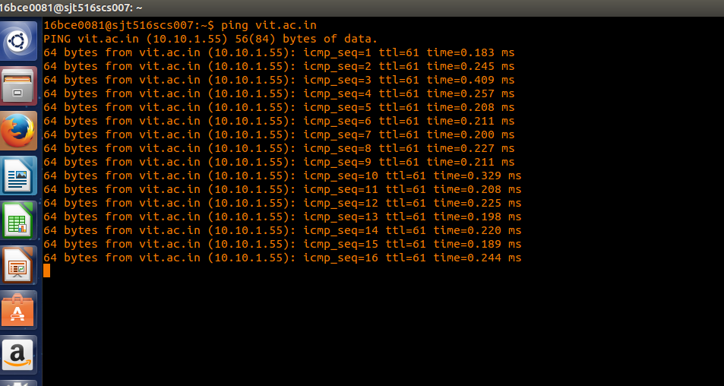

2. netstat

Description: It will tell us what the status of ports are ie. open, closed, waiting connections. It is used to display the TCP/IP network protocol statistics and information.
Command name: netstat
Command Syntax: netstat
Output:
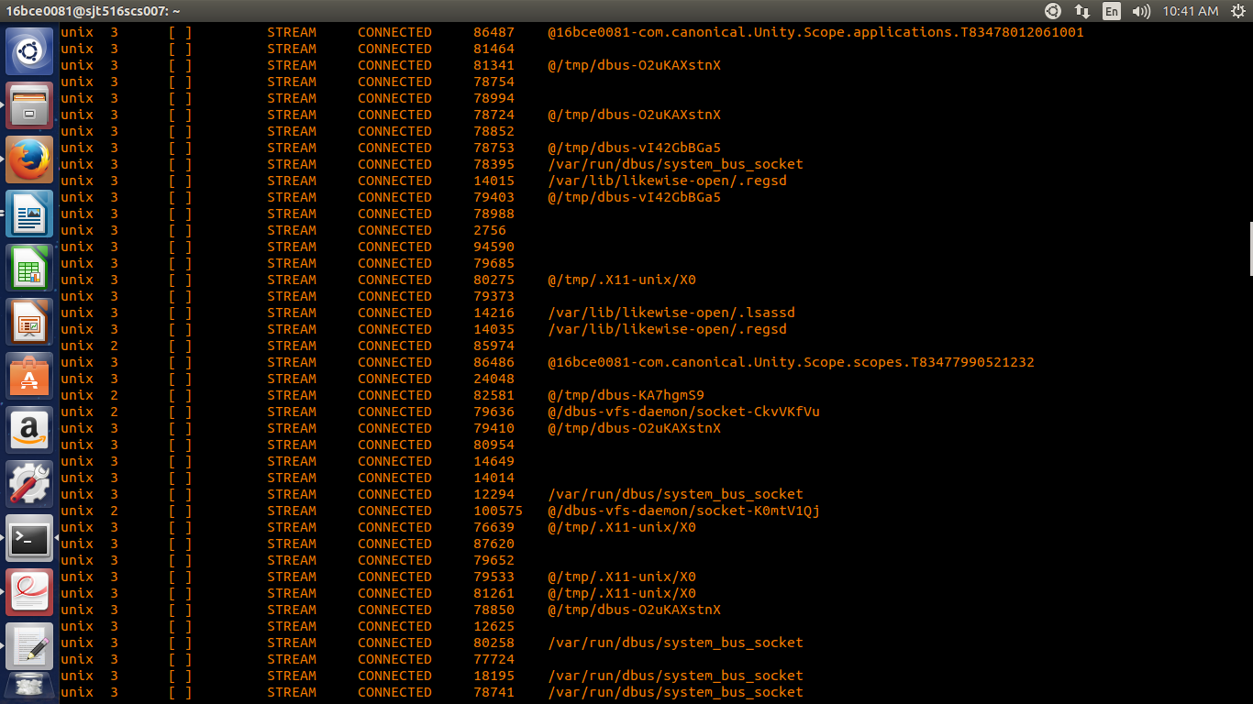

3. tcpdump

Description: This is a sniffer, a program that captures packets off a network interface and interprets them.
Command name: tcpdump
Command Syntax: tcpdump
Output:

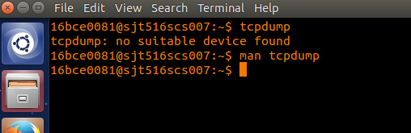

4. hostname

Description: Tells the user the host name of the computer they are logged into.
Command name: hostname
Command Syntax: hostname
Output:

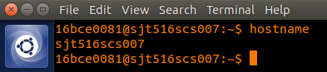

5. traceroute

Description: traceroute will show the route of a packet. It attempts to list the series of hosts through which our packets travel on their way to a given destination.
Command name: traceroute
Command Syntax: traceroute machineName or ip
Output:

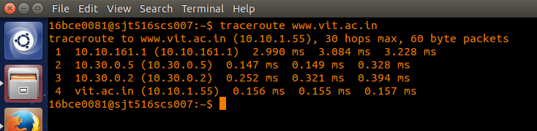

6. finger

Description: Retrieves information about the specified user.
Command name: finger
Command Syntax: finger bce0081
Output:

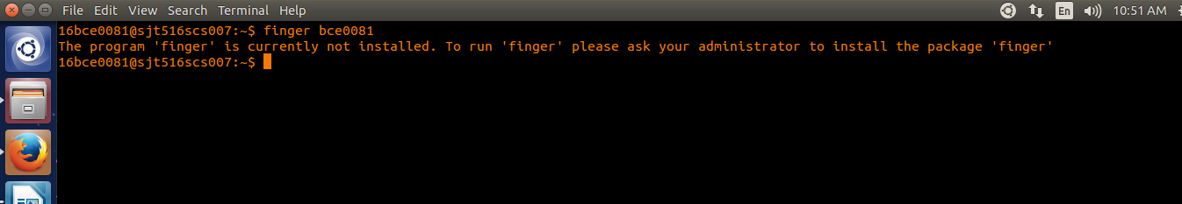

7. ifconfig

Description: This command is used to configure network interfaces, or to display their current configuration.
Command name: ifconfig
Command Syntax: ifconfig
Output:

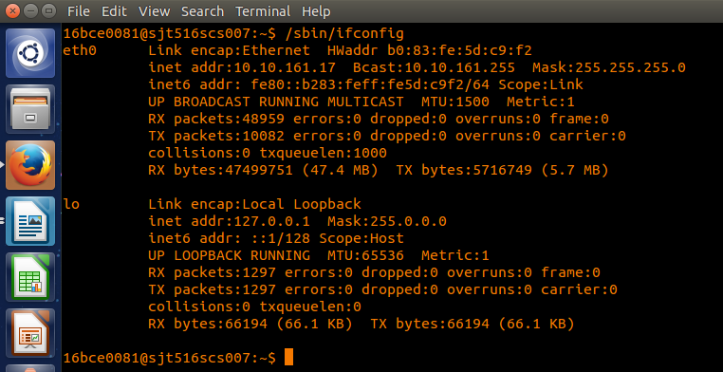

8. dig

Description: The "domain information groper" tool. If a hostname is given as an argument, it outputs information about that host, including it's IP address, hostname and various other information.
Command name: dig
Command Syntax: dig vitlinux
Output:

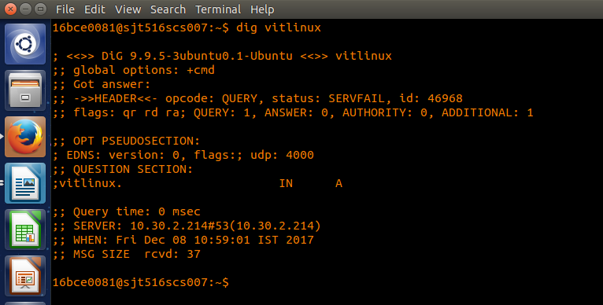

9. telnet

Description: telnet allows you to log in to a computer, just as if you were sitting at the terminal. Once your username and password are verified, you are given a shell prompt. From here, you can do anything requiring a text console.
Command name: telnet
Command Syntax: telnet 16bce2004
Output:

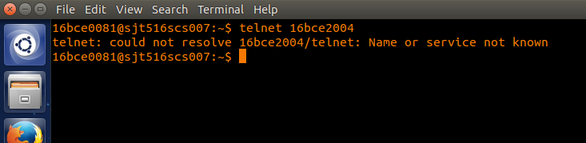
10. ftp

Description: To connect to an FTP server.
Command name: ftp
Command Syntax: ftp 10.10.151.151/lab/
Output:

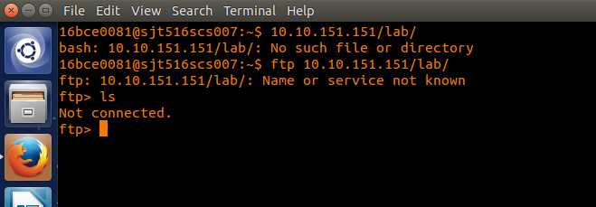

11. nslookup

Description: returns the ipaddress of the given hostname and vice versa.
Command name: nslookup
Command Syntax: nslookup www.vit.ac.in
Output:

